**Name: PARAS RATHI**

**Roll No: BIT-24S-007**

**LAB : 7**

**TASK :1**

**Write a function that takes two numbers and returns their product.**

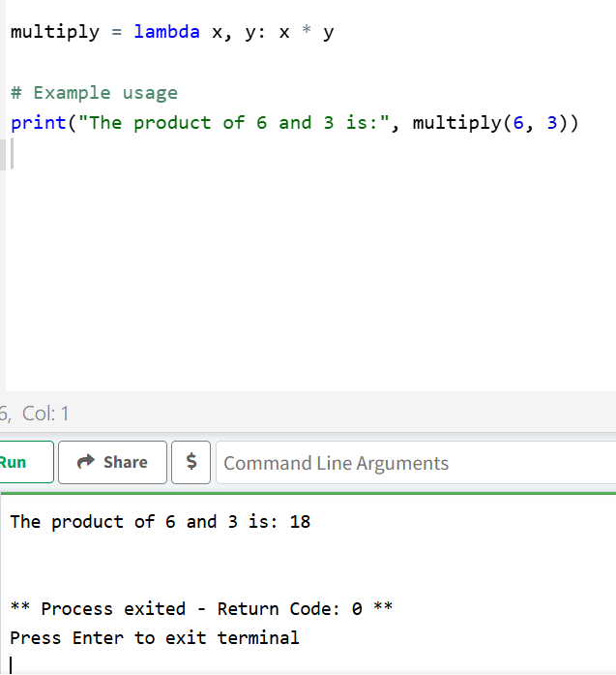

**TASK:2**

**Write a function that checks whether a number is even or odd.**

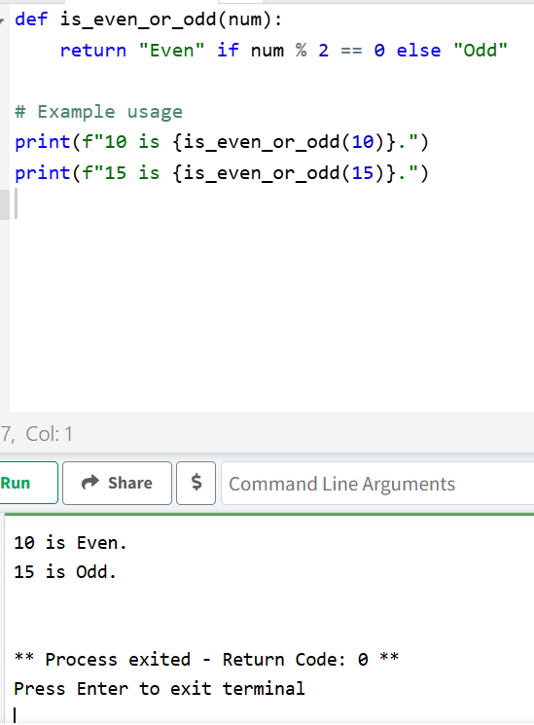

**TASK:3**

**Write a function that takes a name and age and prints a greeting.**

